Inventors are often creative people who invent for many different reasons. Using evidence from the passages, write an essay about why people invent.
Passage 1
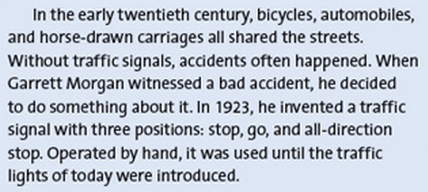
(from www.harcourtschool.com/storytown)
Passage 2
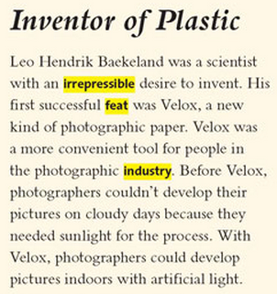
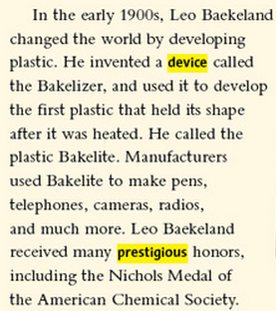
(from Inventor of Plastic, www.harcourtschool.com/storytown)

Passage 3
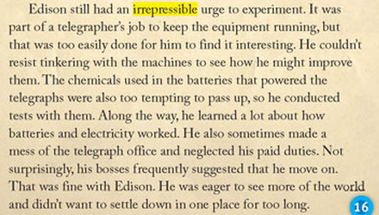
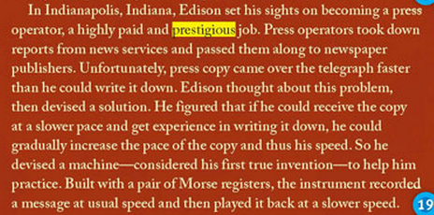
(from Inventing the Future by Marfé Ferguson Delano)

